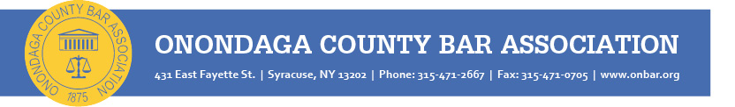

Professional Awards of the Onondaga County Bar Association

Champion of the Law Award

An award given annually (beginning 2024) to a member of the judiciary who has achieved notable success in advancing the interests of justice. Examples of achievements which might support a nomination are contributions to the law, including but not limited to participation in cases or programs that positively impacted the litigants and the legal community; contribution of leadership in implementing improvements to the administration of justice and to access to justice; scholarly published work that advanced education and skills of lawyers in the field; participation in the education and training of bench and bar; generosity of time and effort volunteering time; exhibition of a positive collegial presence, patience without condescension and an outstanding reputation in the legal community.

Rising Star Award

An award given annually (beginning 2024) to a lawyer in the Fifth Judicial District who was admitted no more than ten (10) years prior to the award cycle, who is deemed by their peers as an emerging leader in the practice of law because of their contributions to the profession, the association and the community — and promise of leadership in the future.

Distinguished Lawyer Award

OCBA has been annually honoring a local attorney for distinguished service to the profession since 1968. The OCBA Awards Committee reviews nominations and recommends a candidate to the OCBA Board of Directors for its approval. The Distinguished Lawyer is honored at an event hosted by OCBA each fall. Nominees must have devoted a professional career to the law; must possess exceptional lawyering skills; must display a devotion or dedication to the profession as evidenced by involvement or participation in projects or activities, reflecting an unselfish donation of time to the betterment of the profession and the community; and must possess ethics beyond reproach.

William C. Ruger Centennial Award

The William C. Ruger Centennial Award is given to a current or former judicial officer and is reserved for recognition of singularly outstanding achievement in jurisprudence and devotion to upholding the principles of our system of justice. The Ruger Award was created during the Association’s Centennial celebration in 1975 and named after the first president of the Onondaga County Bar Association, William C. Ruger, who went on to serve as Chief Judge of the New York State Court of Appeals. The Award has been given to only 12 jurists since its inception.

NOMINATION COVER SHEET
To nominate an individual(s) for any of the OCBA Professional Awards, please fill out this cover sheet to submit along with a letter, including the name of the nominee, a resumé or CV, and a description of why the individual meets the criteria for the award. Feel free to include any supporting information (e.g., letters of support) that may be helpful to the Committee when considering this nomination, offering concrete examples of how the nominee has demonstrated the ideals embodied in the award criteria.

☐ Champion of the Law
☐ Rising Star
☐ Distinguished Lawyer
☐ William C. Ruger Centennial Award

Nominee:
Organization:
Title:
Address:
Phone:
Email:

Nominating Individual/Organization
Nominator:
Organization:
Address:
Phone:
Email:

Nominations are accepted on a rolling basis via email to
Jeff Unaitis, OCBA Executive Director (junaitis@onbar.org)
or on our website: https://www.onbar.org/ocba-professional-awards/

While the Committee will accept nominations received for all awards throughout the year, it may not take immediate action on those recommendations, but will maintain all nominations for consideration in subsequent years.

